  - Mississippi Department of Environmental Quality
  - Office of Land and Water Resources
  - Proposal for Ag Chem and Water Levels Data Enhancements​
  - ​

  - ​July 2, 2026


The Geospatial Group
A division of Information Management Systems, Inc.
701 Avignon Drive, Suite 101
Ridgeland, MS 39157

Melanie M Morris
Project Manager
  - ​
Revision History

Version | Date | Description | Author
1.0 | 5/19/2026 | Document Created | Melanie M Morris
1.1 | 5/22/2026 | Document submitted to MDEQ | Gary Hennington
2.0 | 7/1/2026 | Revised for Water Level Measurement Program area modifications | Melanie M Morris
2.0 | 7/2/2026 | Revised document submitted to MDEQ | Melanie M Morris

Introduction
The Geospatial Group is pleased to present this proposal to the Mississippi Department of Environmental Quality (MDEQ) Office of Land and Water Resources (OLWR) for improvements to the MSWIS Ag Chem module and enhancements for the collection and management of Water Level data, including modifications to capture the program for which the individual water levels are measured. Requirements are detailed below.

Ag Chem Requirements
Rq No | Requirement Description
1. | Historical Data needs to be added.
2. | Convert MCLs (Minimum or Maximum Concentration Levels) for all methods to ppb from ppm. (all columns in method 9) This change will be made based on a date to be determined.
3. | Have laboratory results from MSU Chemistry Lab auto populate to MSWIS.  Requirement removed per David Cobb and Mary McKay, email subject: OLWR Roadmap and Ag Chem fixes, dated 6/24/2025.
4. | Change label of ‘Country’ to ‘County’ on Ag Chem Page. Reference Figure 3 Correct County Label Ag Chem Screen  (Ag Chem mswis fixes for Gary, From 3/6 email, item 1)
5. | On Ag Chem page, authorized users need to be able to add new Ag Chem records to wells with ONLY a Permit Number. Currently can ONLY add data via the ‘Well Number’ box; TOP PRIORITY. Will also need a third category – i.e. undocumented (no permit or well number)  (Ag Chem mswis fixes for Gary, From 3/6 email, item 6)
6. | Ag Chem Overview page needs:  “location Description” comment field.  “Comment” field.  ‘Date Drilled’ field next to ‘Attention’ field  (Ag Chem mswis fixes for Gary, From 3/6 email, items 8, 9, and 13)
7. | Group Ag Chem Method 9 Field Methods together at the bottom of the UI page (need to be in same order as received from Lab)  Will need an admin screen to manage the order as well as adding/removing chemicals. This will be managed within each method.  (Ag Chem mswis fixes for Gary, From 3/6 email, item 11)
8. | Add functionality to allow Ag Chem contact information to be populated upon check-out  (Ag Chem mswis fixes for Gary, From 3/6 email, item 14)
9. | Ag Chem Phone # not being populated. Correct this functionality so that it will populate  (Ag Chem mswis fixes for Gary, From 3/6 email, item 15)
10. | Add Photograph if exists, to Ag Chem field sheet  (Ag Chem mswis fixes for Gary, From 3/6 email, item 16)
11. | REQUIREMENT MOVED FROM GLOBAL TO AG CHEM 5/22/2025  The following changes should be made for chemicals: (Note, if admins cannot do this now, the ability to change this information should be added to an admin module.)  - Method-2  - Chlordane_Alpha > No longer tracked (keep in database; remove UI entry)  - Chlordane_Gamma> No longer tracked (keep in database; remove UI entry)  - Toxaphene > No longer tracked (keep in database; remove UI entry)  - Method-3  - Pyrithiobac (Lab) = Pyrithiobac_NA (DEQ)?  - Method-4  - Glusfosinate – Not captured in MSWIS (DEQ) but needs to be added; Important  (Ag Chem mswis fixes for Gary, From 3/6 email, item 17)
12. | Former systems had a button that was [Auto Populate] on the Ag Chem page. Wayne had them take it off, but it is so necessary for data entry. The function of the button is to auto populate ALL chemical fields with a 0.00 right off the bat. This saves so much time just scrolling to any detects and typing in the value over the 0.00 as opposed to mousing and typing 0.00 over 100 times per sample. I would like to add this functionality back to Ag Chem to increase efficiency and lower user data entry error, to be populated by method.  Requirement added per David Cobb and Mary McKay, email subject: OLWR Roadmap and Ag Chem fixes, dated 6/24/2025.
13. | AxoSoft Ticket 1031: Cannot enter Ag Chem records if there is not a Well #.  Also need ability to create a # for a Spring. There will never be a permit. Naming convention should be FIP County (I) xxx. This is how they are currently stored.
14. | Ag Chem searches: Canned query does not work consistently. E.g. Enter 'PCNB’ into [Chemical] and select > 0.00. The query rarely returns any records. For some it does (Iron > 0.0) for example works but most do not.  Requirement added from email dated Tuesday May 12, 2026, email subject: Updated Ag Chem Requirements.
15. | Reformat Ag Chem field sheet.  Requirement added from email dated Tuesday May 12, 2026, email subject: Updated Ag Chem Requirements.
16. | Separate Ag Chem comments from the Water Levels comments.  Requirement added from email dated Tuesday May 12, 2026, email subject: Updated Ag Chem Requirements.

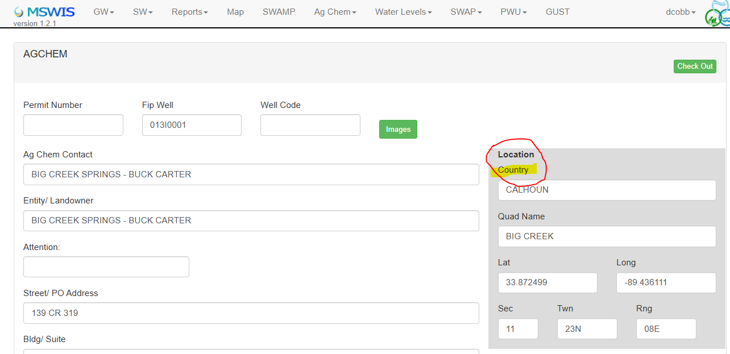
Figure 3 Correct County Label Ag Chem Screen
Requirements that have been struck through have been removed by MDEQ but are included for continuity purposes.
Work associated with the above requirements will include refactoring and implementation of coding efficiencies within the Ag Chem module to support the identified enhancements and promote long-term maintainability.
The estimated timeline for development of the above Ag Chem requirements is approximately 16 weeks.

Water Levels Enhancements Requirements
Rq No | Requirement Description
 | Develop a design to add the ability to enter water level data into ‘Field Sheets’ in MSWIS while in the field using an iPad.
Add three new options for Method of Measurement on the Add New Water Level Data page:
1. Sonic Meter – Eno Scientific Well Watch
2. Sonic Meter – Eno Scientific Well Sounder
3. Sonic Meter – RGI 300
Water Levels ‘Measured For” needs to be saved for the water level measurement and not on the well. This info is currently captured on the water level overview page https://mswis.mdeq.ms.gov/MSWIS/WaterlevelsOverview.aspx but needs to be captured on the water level information page. https://mswis.mdeq.ms.gov/MSWIS/WaterLevelInformation.aspx
Measured For: (Checkboxes)
- State Wide
- NGWMN
- Semi-Annual Survey
- GUST/Metering
- PWS with protection areas
 | All Water Levels currently in MSWIS need to have their measurement type included in the database. This information is provided in Wells_and_WLs_by_Program2.0_Combined.xlsx
 | Update the Generate Field Sheets query to include the water measured for fields https://mswis.mdeq.ms.gov/MSWIS/WaterwellFieldSheets.aspx

The Geospatial Group has evaluated options to provide MDEQ with the ability to enter water level data while in the field. Additional research, understanding, and agreement regarding the functionality to be provided is necessary before a development approach can be finalized. This proposal includes an accelerated design effort to identify and document the business process, requirements, and recommended solution for the Water Levels Data Collection application and includes the following activities and deliverables:
- Two design sessions with MDEQ
- Draft Detailed Design documentation
- One follow-up session for review and validation of the draft design
- Final Detailed Design documentation
The estimated timeline for the Water Levels Enhancements Requirements as detailed in the table above is approximately 6 weeks.

Resources and Cost Table
The Geospatial Group is prepared to begin work under this proposal August 1, 2026.

Module | Resource | Hourly Rate | Hours | Total
Ag Chem | Developer | 135 | 240 | 32400
 | Project Manager | 175 | 32 | 5600
 | Operations Manager | 95 | 32 | 3040
AG Chem Total |  |  |  | 41,040
Water Levels Design | Developer | 135 | 80 | 10800
 | Project Manager | 175 | 16 | 2800
 | Operations Manager | 95 | 16 | 1520
Water Levels Total |  |  |  | 15,120
TOTAL |  |  |  | 56,160

The Geospatial Group proposes the inclusion of supplemental hours equal to 20% of the total estimated hours for the Ag Chem and Water Levels Enhancement requirements. These hours may be used at MDEQ's discretion to address additional requirements identified after execution of the work order. Supplemental hours will be billed only as incurred.
Module | Resource | Hourly Rate | Hours | Total
Supplemental Hours* | Developer | 135 | 64 | 8640
 | Project Manager | 175 | 9 | 1575
 | Operations Manager | 95 | 9 | 855
TOTAL |  |  |  | 11,070

